PROJECT REPORT OF BRAND MANAGEMENT
ON

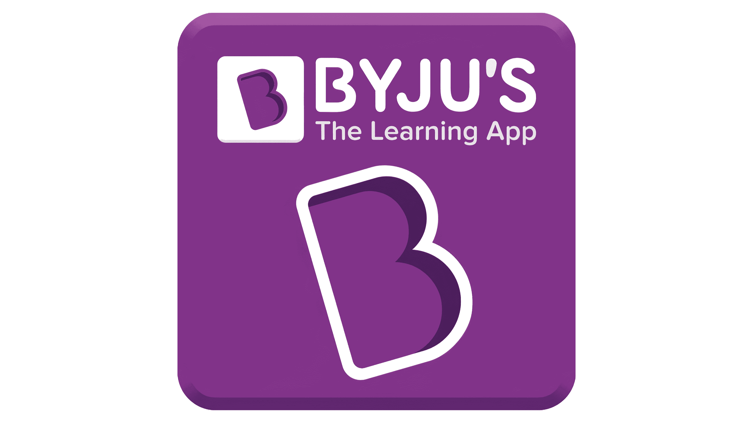

Submitted to:
Prof.Sagar hulbutte

Submitted By:
Amruta.G.Mathadhikari
BCA(U15BH23S0133)
TABLE OF CONTENTS

- COMPANY OVERVIEW:BYJUS
- BRAND HISTORY AND DEVELOPMENT
- BRAND POSITIONING
- BRAND ARCHITECTURE
- BRAND EQUITY OF BYJU’S
- BRAND COMMUNICATION AND PROMOTION
- CUSTOMER PERCEPTION & EXPERIENCE
- SWOT ANALYSIS OF BYJU’S BRAND
- BRAND REVITALIZATION STRATEGIES
- CONCLUSION
- BIBLIOGRAPHY / REFERENCES

Acknowledgement
I would like to express my sincere gratitude to all those who have supported me in the successful completion of this project titled "Brand Management Analysis of BYJU’S".
First and foremost, I extend my heartfelt thanks to Professor Sagar Hulbutte, whose invaluable guidance, insightful feedback, and constant encouragement have played a pivotal role throughout the course of this study. His expertise in the field of marketing and brand management inspired me to explore the subject in depth and approach the project with critical thought and analytical rigor.
Finally, I am grateful to my peers, friends, and family for their unwavering support, patience, and motivation, without which this project would not have been possible.
This project has been a significant learning experience and a stepping stone toward my professional aspirations in brand and product management

Regards
Amruta.G.Mathadhikari
(U15BH23S0133)
SECTION-A

Overview of BYJU’S
BYJU’S is one of India’s leading education technology (edtech) companies, founded in 2011 by Byju Raveendran. Headquartered in Bengaluru, Karnataka, the company initially started as a coaching platform for competitive exams but quickly evolved into a comprehensive learning platform for K–12 students and test preparation across various domains.
The company’s flagship product, BYJU’S – The Learning App, was launched in 2015 and revolutionized digital learning in India by offering engaging, animated video lessons that make complex concepts simple and enjoyable. BYJU’S caters to students from Grade 1 to 12 (K-12) and also offers preparation modules for competitive exams like JEE, NEET, CAT, IAS, GRE, and GMAT.
What sets BYJU’S apart is its personalized and adaptive learning model, which uses artificial intelligence and data analytics to tailor content to individual learning styles and paces. The app’s gamified approach and real-world examples make it a preferred choice among students and parents alike.
Over the years, BYJU’S has expanded through strategic acquisitions, including WhiteHat Jr., Aakash Educational Services, Toppr, and Great Learning, solidifying its position in both domestic and international markets.
Despite facing challenges such as regulatory scrutiny and questions about aggressive sales tactics, BYJU’S continues to be a key player in the global edtech ecosystem, with a strong vision of making high-quality education accessible to students across geographies.
As of recent years, the brand has been associated with prominent marketing campaigns and sponsorships, including partnerships with global sporting events, making BYJU’S one of the most recognized educational brands in India and beyond.

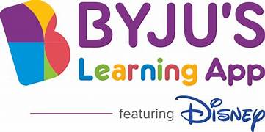

Brand History and Development of BYJU’S
Origin and Early Years (2008–2014)
The roots of BYJU’S trace back to 2008 when Byju Raveendran, a former engineer and CAT topper, began tutoring students for competitive exams. His unique teaching style and conceptual clarity led to increasing popularity through word of mouth. Initially, these were offline classroom sessions under the brand name "Think & Learn Pvt. Ltd."
Launch of BYJU'S – The Learning App (2015)
Recognizing the potential of digital learning, the company launched BYJU'S – The Learning App in 2015. This marked a major shift from physical coaching to digital learning. The app gained rapid popularity due to its engaging video lessons, gamified content, and focus on conceptual understanding.
Growth Phase and Expansions (2016–2019)
During this period, BYJU’S witnessed exponential growth:
- Received funding from major investors including Sequoia Capital, Chan Zuckerberg Initiative, Tencent, and General Atlantic.
- Expanded curriculum offerings for Grades 4–12 and introduced test prep content (JEE, NEET, CAT, IAS).
- Crossed over 10 million downloads and became India's most-valued edtech startup.
Strategic Acquisitions (2019–2022)
To strengthen its ecosystem and enter new segments, BYJU’S made several key acquisitions:
- WhiteHat Jr. (2020): Coding for kids.
- Aakash Educational Services (2021): Strong presence in offline and test prep market.
- Toppr & Great Learning: Focus on K-12, higher education, and upskilling.
These acquisitions helped BYJU’S offer a 360-degree learning solution from school to career.
Global Presence and Branding (2021–Present)
BYJU’S expanded internationally into the U.S., U.K., Middle East, and Australia. It also focused on brand building through:
- Partnerships with global entities like FIFA World Cup, ICC, and BCCI.
- Celebrity endorsements by Shah Rukh Khan, and others.
Challenges and Strategic Shifts (2022–2024)
Despite success, BYJU’S faced challenges:
- Criticism over aggressive sales tactics.
- Financial scrutiny and delays in filings.
- Layoffs and restructuring.In response, the company began focusing on profitability, core learning products, and streamlining operations. It also emphasized personalized learning, teacher-led hybrid models, and rural outreach to bridge educational gaps.
Brand Positioning:
Target Audience & Segmentation
- Primary Users: K-12 students, competitive exam aspirants, and lifelong learners.
- Decision Makers: Parents (especially for K-12 segment), who are influenced by the brand’s credibility and value proposition.
- Positioning Focus: Targets privileged, multitasker segments who can afford premium digital learning products, fulfilling their need for quality, convenience, and results.

Key Elements of BYJU’S Brand Positioning
1. Personalized, Technology-Driven Learning
- BYJU’S uses AI, machine learning, and data analytics to deliver adaptive, personalized learning paths, making lessons engaging and tailored to individual student needs.
- Gamification and interactive content are core to the platform, making learning “fun” and effective.
2. Innovative & Accessible Education
- BYJU’S positions itself as an innovator, leveraging technology to bridge educational gaps and provide access to quality education across India and globally.
- The brand’s expansion through acquisitions (e.g., Osmo, WhiteHat Jr., Epic) has broadened its product portfolio and international reach.
3. Trust & Credibility
- Heavy investment in marketing, including celebrity endorsements (Shahrukh Khan, Mahesh Babu), sports sponsorships (Indian cricket team, ICC, FIFA World Cup), and partnerships with schools, have built strong brand recall and trust.
- Campaigns like “Keep Learning” and “Fall in Love with Learning” reinforce the brand’s commitment to lifelong learning and positive change in study habits.
4. Localized & Inclusive Approach
- BYJU’S runs regional campaigns in multiple Indian languages, using local celebrities to connect with diverse audiences and ensure inclusivity.
- Advertisements emphasize the joy and effectiveness of online learning, targeting both students and their parents.

Positioning Statement Example
“BYJU’S is positioned as India’s most trusted and innovative digital learning platform, empowering students to achieve academic excellence through personalized, engaging, and technology-driven education, accessible anytime and anywhere.”

Attribute | BYJU’S Approach
Core Promise | Personalized, enjoyable, and effective learning
Differentiator | AI-powered adaptive content, gamification, celebrity trust
Target Audience | K-12 students, exam aspirants, parents
Emotional Appeal | Learning is fun, empowering, and future-focused
Functional Benefit | Improved academic performance, convenience, accessibility

Brand Positioning Visualized
Challenges & Criticisms
- High pricing limits access for lower-income groups, despite a freemium entry point.
- Aggressive marketing and financial mismanagement have led to recent reputation and valuation challenges.
- Over-expansion and acquisition of unprofitable ventures have impacted financial stability.

BYJU’S brand positioning is rooted in technology-enabled, personalized learning for students, supported by aggressive marketing, strategic partnerships, and a focus on trust and accessibility. Its campaigns and innovations have made it a household name, though recent challenges highlight the importance of sustainable growth and reputation management

Brand Architecture of BYJU’S
BYJU’S has developed a multifaceted brand architecture to support its rapid growth, diverse offerings, and global expansion. Its structure reflects a “House of Brands” approach, where the parent brand (BYJU’S) owns and manages a portfolio of sub-brands and acquired companies, each targeting specific segments within the education sector.
1. Parent Brand: BYJU’S
- Core Offering:
BYJU’S is the flagship brand, primarily known for its digital learning platform targeting K-12 students and competitive exam aspirants in India and abroad.
- Brand Promise:
High-quality, engaging, and personalized education through technology-driven solutions.
2. Sub-Brands and Product Lines
- BYJU’S The Learning App:
The main product for K-12 students, offering interactive video lessons and adaptive learning journeys.
- BYJU’S Early Learn:
Focuses on early childhood education, often in partnership with Disney, targeting young learners with gamified and story-driven content.
- BYJU’S Classes:
Provides live online tutoring and doubt-solving sessions for students seeking real-time interaction with educators.
- BYJU’S Exam Prep:
Caters to students preparing for competitive exams (e.g., JEE, NEET, IAS) with specialized content and test series.
3. Acquisitions and International Brands
BYJU’S has expanded its brand architecture through strategic acquisitions, integrating these brands under its umbrella while often retaining their original identities:
- WhiteHat Jr:
Coding and technology education for children, operating as a distinct brand but endorsed by BYJU’S.
- Osmo:
US-based company specializing in blended physical-digital learning tools for children.
- Epic:
Leading digital reading platform for kids in the US.
- Aakash Educational Services:
Major Indian test prep brand, known for offline and online coaching for medical and engineering entrance exams.
- Toppr, Great Learning, TutorVista, Scholar, and others:
Each addresses specific niches such as higher education, up skilling, and personalized tutoring.

4. Brand Guidelines and Visual Identity
- BYJU’S maintains a unified visual identity across its core and sub-brands, ensuring consistency in colour palette, logo usage, and design elements.
- Acquired brands may retain their own visual identities but are often “endorsed by BYJU’S” to leverage the parent brand’s credibility and reach.
5. Strategic Rational
- Segmentation:
Each sub-brand or acquisition targets a unique audience segment—from preschoolers to adult learners, and from Indian to global markets.
- Synergy:
Cross-promotion and integration of services (e.g., combining BYJU’S content with Aakash’s test prep expertise) create value for users and strengthen the brand ecosystem.
- Market Expansion:
The architecture allows BYJU’S to quickly enter new markets and categories without diluting the core brand’s identity.
Brand/Division | Target Segment | Core Offering | Status
BYJU’S The Learning App | K-12 students | Digital learning, video lessons | Core Brand
BYJU’S Early Learn | Young children | Gamified early education | Sub-Brand
BYJU’S Classes | K-12 students | Live tutoring | Sub-Brand
BYJU’S Exam Prep | Exam aspirants | Competitive exam prep | Sub-Brand
WhiteHat Jr | Coding for kids | Coding & tech courses | Acquisition
Osmo | Young children (global) | Physical-digital learning tools | Acquisition

BYJU’S brand architecture is a robust, multi-layered system combining its own sub-brands with a portfolio of acquisitions. This approach enables BYJU’S to serve diverse educational needs, expand globally, and maintain strong brand equity while leveraging the strengths of specialized brands within its ecosystem

Brand Equity of BYJU’S
5.1 Introduction to Brand Equity
Brand equity refers to the value a brand adds to a product or service, as perceived by consumers. Strong brand equity results in customer loyalty, premium pricing, and market competitiveness. It is built over time through consistent brand experiences, visibility, and trust.
5.2 Dimensions of Brand Equity (Based on Aaker’s Model)
1. Brand Awareness
- BYJU’S enjoys high top-of-mind recall in the EdTech space, especially in India.
- Massive advertising campaigns with celebrities like Shah Rukh Khan and global visibility through partnerships like ICC & FIFA.
- Strong digital presence with over 150 million registered users globally (as of recent reports).
2. Brand Associations
- Innovation: Known for using animation, gamification, and personalization in learning.
- Trust in Quality: Associated with quality educational content from experienced educators.
- Modern Learning: Associated with terms like "AI-based learning," "online tuition," and "visual content."
- Success-Oriented: Seen as a guide to academic and exam success.
3. Perceived Quality
- High-quality visual lessons with real-life examples and personalized feedback.
- Strong content partnerships (Disney BYJU’S Early Learn, Aakash Institute).
- User testimonials and parent feedback reinforce its educational impact.
4. Brand Loyalty
- Subscription-based model fosters continued engagement.
- Parent and student referrals are a major growth driver.
- However, brand loyalty has been slightly impacted due to:
  - Reports of aggressive sales tactics
  - Customer dissatisfaction in Tier-2/3 regions
5. Proprietary Brand Assets
- Strong brand identity and logo recognition.
- Trademarked apps and content platform.
- Strategic acquisitions (WhiteHat Jr, Aakash, Great Learning) increase market control and equity.

5.3 Keller’s Customer-Based Brand Equity (CBBE) Pyramid Applied to BYJU’S
Level | BYJU’S Position
Salience (Awareness) | High – Recalled as India’s leading EdTech company
Performance | Strong content, visual learning, progress tracking
Imagery | Seen as modern, futuristic, elite
Judgments | Mixed – High quality but concerns over pricing & service
Feelings | Confidence, achievement, curiosity
Resonance (Loyalty) | Moderate – Usage depends on exam prep need, but high retention among premium users

5.4 Current Challenges to Brand Equity
- Trust issues due to complaints over refund policy and aggressive selling.
- Affordability concern among price-sensitive parents.
- Brand dilution risk due to multiple acquisitions and offerings.
5.5 How BYJU’S Enhances Brand Equity
- Heavy investment in marketing and CSR initiatives (e.g., Education for All program).
- Expanding into offline learning center via Aakash BYJU’S.
- International expansion through localized versions of its app.
5.6 Brand Equity Metrics
Metric | Status
Brand Valuation | Over $22 billion (peak valuation, 2022)
Customer Retention | ~75% (based on subscription renewal data)
Brand Recall in Category | Among Top 2 EdTech brands in India
Brand Endorsement | Global celebrities, sports sponsorships
Net Promoter Score (NPS)* | ~35–40 (estimate based on reviews)

BYJU’S has built strong brand equity through high awareness, innovative content, and strategic partnerships. However, to sustain and grow this equity, the company needs to restore consumer trust, enhance affordability, and strengthen service quality in the face of rising competition.

Brand Communication and Promotion of BYJU’S
6.1 Introduction
BYJU’S, India’s leading EdTech brand, has revolutionized digital learning with its high-impact communication strategies. Its promotion efforts combine traditional marketing, digital outreach, celebrity endorsements, and educational campaigns, all aligned to position the brand as innovative, trustworthy, and learner-centric.
6.2 Objectives of Brand Communication
- Create Awareness about BYJU’S learning solutions across age groups.
- Build Trust and credibility in the EdTech domain.
- Differentiate from competitors by showcasing technology-led learning.
- Drive Conversions by motivating users to sign up or purchase plans.
- Establish Emotional Connection with students and parents.
6.3 Key Channels of Communication
1. Television Advertising
- Heavy investments in TV commercials targeting parents during prime time.
- Ads aired on kids' and general entertainment channels like Cartoon Network, Sony, and Star Plus.
- Messaging often includes:
  - "Fall in love with learning"
  - "Learn from the best teachers with personalized support"
2. Digital Marketing
- YouTube Ads: Engaging, animation-based explainer videos.
- Google Display Network: For app promotion and remarketing.
- SEO & SEM: Focused on exam prep keywords (JEE, NEET, CAT, etc.).
- Email & SMS Campaigns: Regular updates, trial offers, and event promotions.
- Push Notifications: App-based nudges to drive course completion.
3. Celebrity Endorsements
- Shah Rukh Khan was the face of the brand for multiple years.
- These endorsements increased relatability and trust with Indian families.
4. Sponsorships and Events
- ICC & FIFA Sponsorships: BYJU’S was an official sponsor of the ICC Cricket World Cup and FIFA World Cup.
- Edu-events: Webinars, learning festivals, and live masterclasses for brand visibility and lead generation.
5. Social Media Marketing
- Platforms: Instagram, LinkedIn, Facebook, Twitter.
- Content types:
  - Student testimonials
  - Fun facts and educational content
  - Influencer collaborations
  - Behind-the-scenes and teacher interviews
6. In-App & Website Communication
- Personalized dashboards, onboarding emails, trial prompts.
- Gamification messages: “You’ve completed 80% of your course. Keep going!”
7. ATL/BTL Promotions
- ATL (Above the Line): Mass media campaigns for large-scale reach.
- BTL (Below the Line):
  - School partnerships
  - Free trial campaigns
  - Learning centers pop-ups in malls and public areas.
6.4 Message Strategy
Component | Message Strategy Example
Target | Students (K-12, competitive exams), parents, educators
Tone | Aspirational, friendly, empowering
Key Themes | Personalization, visual learning, academic success
CTA (Call to Action) | “Book a free class”, “Download now”, “Start learning”

6.5 Promotion Mix (IMC Approach)
Tool | Usage by BYJU’S
Advertising | TV, print, online, celebrity endorsements
Sales Promotion | Free trials, early-bird discounts, scholarship tests
Direct Marketing | Emails, app notifications, phone demos
PR/Publicity | Press releases, educational CSR campaigns
Sponsorship | ICC & FIFA, Olympic athlete collaborations
Personal Selling | Tele-counselors and education advisors

6.6 Recent Campaigns
“Come Fall in Love with Learning”
- Aimed at removing fear of learning.
- Animated, storytelling-based ad visuals.
“Keep Learning. Keep Growing”
- During COVID-19 pandemic, focused on continuity of education.
BYJU’S Education for All (CSR Communication)
- Reached out to underprivileged children with free content.
6.7 Challenges in Brand Communication
- Over-communication leading to user fatigue.
- Perception gap due to aggressive sales tactics.
- Misalignment between promises in marketing and actual service experience.
6.8 Recommendations
- Focus more on trust-building communication post-2023 controversies.
- Enhance two-way communication with students (via community platforms).
- Localize messaging for Tier-2/3 India with vernacular content.
- Invest in customer service communication to reduce attrition.

BYJU’S has adopted a multi-faceted communication strategy that leverages both emotional appeal and performance-driven content. While its promotions have built strong visibility, the next stage must focus on brand trust, customer-centric messaging, and sustainable engagement.

Customer Perception and Experience of BYJU’S

7.1 Introduction
Customer perception refers to how users view and feel about BYJU’S — shaped by advertising, user experience, peer feedback, and outcomes. As an EdTech brand, BYJU’S customer experience is critical to its success, especially as it targets both students and their parents.
7.2 Key Influencers of Customer Perception
Factors | Description
Product Quality | Interactive video lessons, personalized learning paths, app responsiveness
Marketing & Branding | High-visibility campaigns, celebrity endorsements (e.g., Shah Rukh Khan)
Word of Mouth | Peer reviews from parents and students
Customer Service | Call support, counselor interaction, refund/return experience
Educational Outcome | Exam preparation success, academic improvement

7.3 Positive Perceptions
Innovative Learning:
- Many parents and students appreciate the animated, visual content and personalized learning approach.
- Children find the app engaging and less intimidating compared to traditional textbooks.
Trusted Brand:
- The wide use across India and international markets boosts its brand credibility.
- Top-of-mind recall in the EdTech category.
Exam Preparation Support:
- NEET, JEE, CAT, and UPSC aspirants value the structured learning paths and mock tests.
Wide Accessibility:
- Available in both app and tablet formats.
- Used across metros and Tier 2/3 cities.

7.4 Negative Perceptions
Aggressive Sales Tactics:
- Many users have reported persistent follow-ups and high-pressure sales, particularly when targeting parents.
- This has led to trust issues and negative media coverage in recent years.
Overpromising Outcomes:
- Claims about guaranteed academic success are sometimes perceived as exaggerated.
Customer Service Complaints:
- Refund issues, lack of responsiveness, and confusing cancellation policies have hurt the experience for some.
Pricing Concerns:
- Some parents find the pricing not affordable, especially for mid-income families.

7.5 Data Insights (if applicable)
According to reports (from user reviews, Trustpilot, etc.):
- App Rating: ~4.1 stars on Play Store (as of last public review)
- Net Promoter Score (NPS): Varied significantly before and after controversies
- Customer Service Rating: Mixed — around 3.0/5 on public platforms

7.6 Customer Journey
Stage | Experience Summary
Awareness | Driven by digital ads, celebrity endorsements, school campaigns
Interest | Free demo sessions or trial app version offered
Evaluation | Interaction with counselors and comparison with competitors
Purchase | Online sign-up or subscription with upfront payment
Post-Purchase | Regular learning, access to mentor teachers, app support
Retention/Exit | Risk of dissatisfaction if expectations not met; cancellation challenges reported

7.7 Experience Touchpoints
- App UI/UX – Visually appealing, user-friendly.
- Live Classes – Helpful but sometimes overcrowded.
- Mentorship Calls – Vary in quality depending on region/advisor.
- Tech Support – Mixed feedback.
- Content Quality – Often rated highly for clarity and visualization.

7.8 Customer Testimonials (Sample Format)
“My daughter finds math interesting for the first time, thanks to BYJU’S engaging video lessons.” – Parent from Hyderabad
“Great content, but too many follow-up calls before and after purchase.” – Student from Pune

7.9 Summary of Insights
Strengths | Weaknesses
Engaging, personalized content | Aggressive sales tactics
Strong brand image | Customer service inconsistency
Wide subject coverage for exams | High pricing barriers for some segments
Easy app accessibility | Mismatch between expectations and delivery

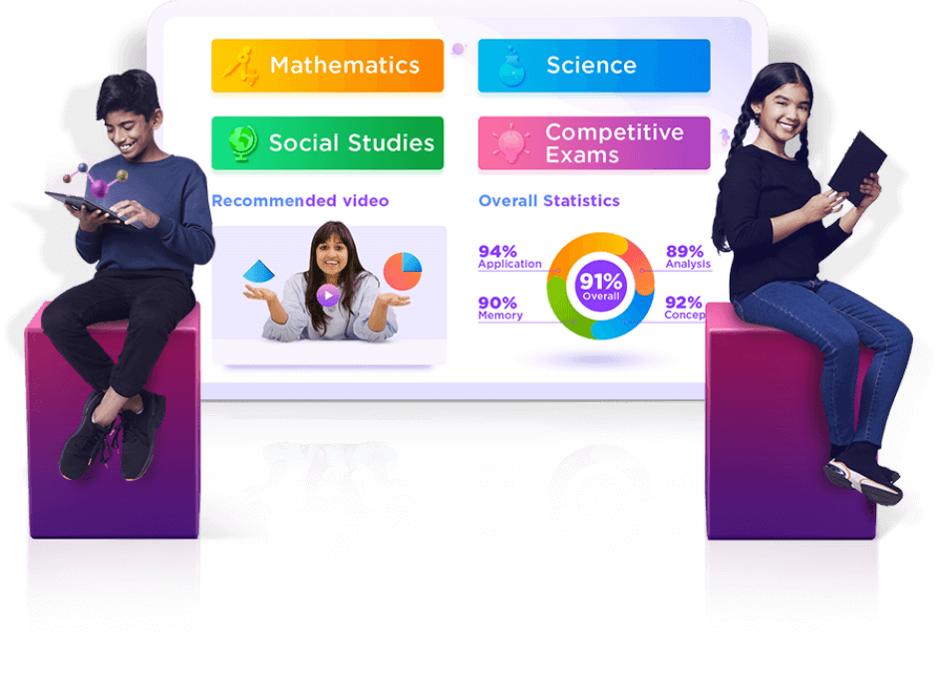
SWOT ANALYISIS
9.2 SWOT Matrix
Category | Details
Strengths | - Strong brand recall as India’s No. 1 EdTech platform  - Wide product range (K–12, competitive exams, coding, etc.)  - Acquisitions like Aakash, Toppr, WhiteHat Jr. for market diversification  - Celebrity endorsements and high brand visibility  - Strong mobile and digital infrastructure  - Personalized learning experience via AI/ML
Weaknesses | - Aggressive and unethical sales practices damaging brand image  - High course fees reducing affordability  - Customer service issues and refund complaints  - Over-dependence on paid subscriptions  - Poor integration and synergy after multiple acquisitions  - High cash burn and financial stress
Opportunities | - Growing demand for online learning and hybrid models  - Potential expansion in Tier 2 & Tier 3 cities and global markets  - Collaborations with schools and government education programs  - Rise in AI-powered adaptive learning tools  - Growing demand for skill-based learning (e.g., coding, soft skills)
Threats | - Intense competition from Unacademy, Vedantu, PhysicsWallah, etc.  - Free and trusted platforms like Khan Academy, YouTube, and Google Learning  - Regulatory scrutiny from ASCI and consumer forums  - Negative PR and media backlash affecting trust  - High dependence on India's EdTech market (less global diversification)

9.3 Strategic Insights
- Strength–Opportunity Match: BYJU’S can use its strong digital platform and established brand identity to expand into international and vernacular markets, leveraging hybrid learning.
- Weakness–Threat Management: It must work on ethical marketing, customer service improvements, and financial consolidation to survive growing external threats and avoid further damage to its reputation.

Brand Revitalization Strategies for BYJU’S:
10.1 Introduction
Brand revitalization refers to strategic efforts made to reignite consumer interest, repair brand image, and adapt to market changes. With recent challenges—such as customer dissatisfaction, media criticism, and financial strain—BYJU’S requires a thoughtful brand revitalization roadmap.

10.2 Need for Revitalization
- Declining public trust due to aggressive sales tactics
- High-profile executive resignations and layoffs
- Competition from more affordable and transparent EdTech platforms
- Complaints over refunds, product value, and miscommunication
- Deteriorating brand perception among parents and students

10.3 Revitalization Strategies
1. Repositioning the Brand Ethically
- Shift messaging from “fear of failure” to “empowerment through knowledge”
- Highlight real success stories and positive transformations
- Position as student-first and value-based, not profit-driven
2. Transparent Sales and Customer Practices
- Eliminate hard-selling and misleading marketing
- Launch a parent advisory board or customer support reforms
- Offer transparent refund and feedback systems
3. Product Re-engineering
- Introduce modular pricing and flexible subscriptions
- Enhance personalized learning algorithms for better engagement
- Expand low-cost options for underprivileged students
4. Strengthening Teacher and Mentor Quality
- Recruit and showcase expert educators
- Offer live mentoring, doubt-solving, and more interactivity
- Invest in teacher branding (like MasterClass approach)
5. Targeted Regional Expansion
- Develop vernacular content and local curriculum support
- Collaborate with state education boards and rural schools
6. Rebranding through Campaigns
- Launch a “Back to Learning, Back to Trust” campaign
- Utilize testimonials, case studies, and CSR initiatives
- Partner with credible influencers and educators, not celebrities
7. Streamlining Acquisitions
- Integrate past acquisitions (like WhiteHat Jr, Aakash) into a single unified brand experience
- Close or rebrand underperforming subsidiaries
8. Mental Health & Learning Balance
- Add modules for student well-being, stress management, and digital detox
- Brand as a holistic education partner, not just an exam machine
10.4 Long-Term Revitalization Goals
- Rebuild trust with parents, students, and stakeholders
- Stabilize finances through sustainable growth strategies
- Become a globally respected EdTech leader with social impact

Conclusion
This project provided a comprehensive analysis of BYJU’S as a brand, tracing its journey from a niche test-prep app to becoming one of India’s most recognizable EdTech giants. Through the lenses of brand history, positioning, communication strategies, customer perception, and SWOT analysis, we gained valuable insights into both the strengths and challenges of the brand.
BYJU’S has successfully leveraged technology, personalized learning, and aggressive marketing to build a strong presence in the education sector. However, in recent years, its brand credibility has been challenged by negative customer experiences, aggressive sales practices, and growing competition.
To sustain and strengthen its brand equity, BYJU’S must undergo strategic revitalization—focusing on ethical repositioning, transparent customer relationships, and value-driven innovation. With the right reforms, the brand has the potential to regain public trust and reaffirm its position as a leader in digital education.
Ultimately, the BYJU’S case serves as a compelling example of how brand management is not just about visibility, but about creating meaningful and trustworthy connections with consumers.

Suggested References
- BYJU’S Official Website
https://byjus.com
- Annual Reports & Press Releases – BYJU’S
- Statista Reports on EdTech Industry in India
https://www.statista.com
- LinkedIn & Company Blogs of BYJU’S

